Antigravity Drive Software Control System

Design Report
CEN3913 – Spring 2015

Oglethorpe P. Bushmaster
24 Mar 2015

Abstract
In this project, we design and construct a software control system for a Biefield-Brown antigravity drive. The software is controlled by an Android or iPhone interface that allows the user to program all the relevant system parameters. The motivation for this project comes from a NASA research grant that has as its focus the development of alternative satellite propulsion systems.
Several expected challenges are overviewed in this design report. Firstly, we expect that power consumption of the drive unit will be sufficiently high that our control CPU can be accommodated in the consumption profile of the power system. Secondly, questions have arisen in the research community regarding the viability of this antigravity drive concept in the absence of an ambient magnetic field. If time permits, we will test this potential limitation.

1 Introduction
In the Autumn of 2003, researchers at RCA Laboratories re-discovered the Biefield-Brown effect (BBE), which was initially reported by T. Townsend Brown in 1936 [-ref], and is exemplified in Figure 1. The BBE appears to be due to coulombic repulsion, but several recent tests have questioned whether or not there is another component, namely, interaction with the ambient magnetic field (e.g., Earth’s magnetic geoid) [-ref].
In this project, we explore the design and construction of a software control system for a Biefield-Brown antigravity drive. Our software is designed to be controlled by an Android or iPhone interface that allows the user to program all the relevant system parameters.

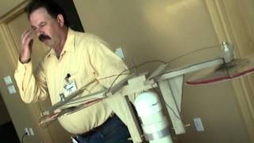
Figure 1. Photograph of simple Biefield-Brown apparatus.
This report discusses the design of the software control system which we call Anti-Gravity Software Control (ASOC). In particular, we discuss the structure and function of our system, and how the design relates to our implementational objective of mobile wireless device control.
Several expected challenges are overviewed in this design report. Firstly, we expect that power consumption of the drive unit will be sufficiently high that our control CPU can be accommodated in the consumption profile of the power system. Secondly, questions have arisen in the research community regarding the viability of this antigravity drive concept in the absence of an ambient magnetic field. If time permits, we will test this potential limitation.
2 Structure and Function of the System
As discussed in [BBEYT], the BBE demonstration apparatus can be constructed with balsa wood, aluminum foil and glue, as well as a high-voltage supply connected to the levitation structure with fine copper wire (approximately 60 gauge). Video directions are given in a YouTube presentation [BBEYT].
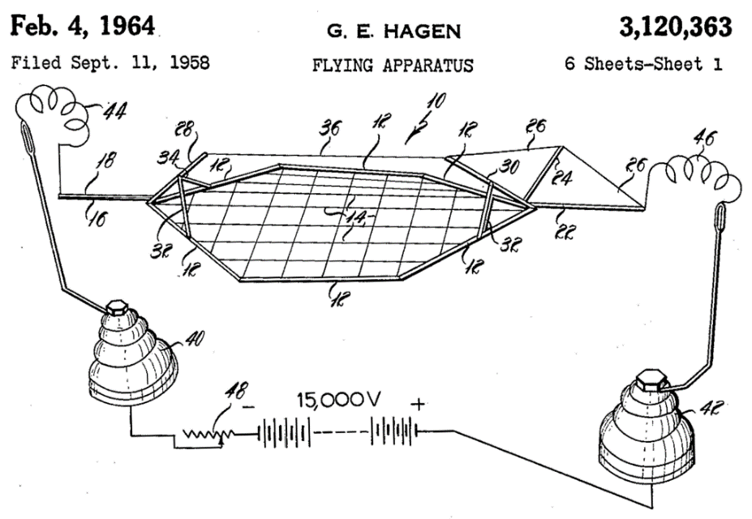
Figure 2. Diagram of Biefield-Brown test apparatus in US Patent # 3,120,363.
The functionality of the BBE lifter described in [BBEYT] is not well understood [San10,TTB34,Val12]. Some authors suggest that its operation is due solely to Coulombic repulsion, while others note that such charge effects cannot account for all the force produced. Thomas Townsend Brown, the inventor of the well-known devices that instantiate the Biefield-Brown effect, has suggested a linkage between electromagnetism and gravitation that has been discussed extensively in the literature [Wri14].
3 Design Approach and Analysis
Our design approach is based on agile development, whereby we have multiple iterations through the envisioning – design – analysis – coding – debugging – testing cycle found in the waterfall model. This process is illustrated notionally in Figure 3. Agile development has the advantages of speed, flexibility to meet customer requirements, reduced design and coding errors resulting in less rework, and increased reliability and robustness.
Within each scrum, we will develop another phase of the project. For example, Scrum 0 will involve literature research and envisioning the functioning form of the product, including a graphical user interface (GUI) for controlling the BBE “lifter”. Scrum 1 will emphasize construction of a basic balsa-wood lifter structure, with supporting electronics comprised of an AC power supply feeding a flyback transformer from a cathode-ray-tube (CRT) television set. The electronics will be controlled by a software-controlled VariacTM transformer.
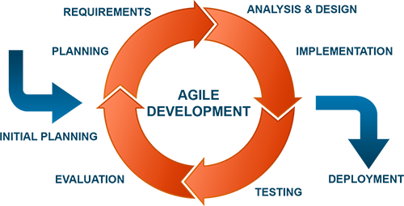
Figure 3. Notional diagram of agile development methodology.

Scrum 2 will include but not be limited to testing and enhancing the software interface, as well as introducing a variable-frequency RF activation coil in place of the flyback transformer. Additionally, we will conduct incremental testing of each subsystem (e.g., power supply, coil, lifter, and software interface). Scrum 3 will be focused on further enhancing, analyzing and improving the prototype, with system-wide test and analysis of test results.
4 Anticipated Technical Challenges and Possible Solutions
We expect the following technical challenges to present in construction of the software control for the BBE demonstration using a Townsend-Brown type of lifter described in [TTBYT]:
- Obtaining a Software-Controlled High-Voltage Transformer that will be required to vary the input voltage to the BBE lifter mechanism.
Solution: We propose to search the electronic hardware supply firms on the Web and procure a simple software-controlled voltage and current adjustable power supply, which will produce a power signal that will be input to a high-voltage transformer such as a flyback transformer found in an analog television set. We will then interface this software-controlled power supply with the transformer to produce a software-controlled high-voltage radio-frequency power source.
- Configuring the Lifter to Produce Optimally Sensitive Lift as a Function of Applied Power which will help us to more extensively investigate the dependence between lift force and applied voltage and current.
Solution: We propose to apply the design equations in [TTB34] as well as [San10,Val12] to make the Lifter architecture optimally responsive and sensitive to applied voltage and current.
Additional challenges will be addressed as they present, and solutions will be derived to fulfill the project objective, namely, researching and developing a software controller for a BBE lifter.
5 Preliminary Design Conclusions
A design report has been presented for a Biefield-Brown effect (BBE) levitation device that is expected to produce vertical thrust in the downward direction to effect “liftoff” from a horizontal surface such as a laboratory table or desk. We propose to develop this device and its associated software controller interface in Java Script with Angular.js. Development will proceed according to an agile model (see Figure 3), which is expected to increase reliability and decrease error, rework cost, and overall development time.
References
[BBEYT] HVLabs.com (2007), “High Voltage Lifter Ion Craft - A ‘How to documentary’”, YouTube video: http://www.youtube.com/watch?v=XKi9OOS-e94 (as-of 28 Oct 2014).
[San10] Sandburg, J. (2010), Electromass: The Same Principles at Every Scale, Bloomington IN: iUniverse Books.
[TTB34] Brown, T. T. (1934), “Electrostatic Motor”, US Patent 1,974,483.
[Val12] Valone, T. (2012), “Electrokinetics as a propellantless propulsion source”, Physics Procedia 38: 87-98.
[Wri14] Wright, S.E. (2014), Unification of Electromagnetism and Gravity: A New Relativity Theory, Trafford Publishing (www.trafford.com), p. 16.

