DESIGN REPORT

ANTIGRAVITY MACHINES FOR THE MASSES

James Carnegie
Group Members: Alison Chang, Jose Hernandez
University of Florida ⋅ Department of CISE ⋅ Gainesville, FL 32611-6120

CEN 3913 – Fall 2015
V0.1 Early Draft 27 Oct 2015

Introduction
This report summarizes design activity for the Antigravity Project in CEN 3913, Fall Semester 2015. The Antigravity research effort at UF has yielded several new devices, one of which is based on the Biefield-Brown Effect, as described herein. …..MORE….
An indented paragraph…

Project Background
For centuries, people have speculated about unassisted flight – wouldn’t it be nice to have the wind beneath your wings, so to speak?

Technical Approach
We will construct a Biefield-Brown effect device that appears to levitate in the presence of an applied electric field. The construction technique will utilize balsa wood, fine copper wire, and aluminum foil. The devise will be ocnected to a high-voltage RF power supply in the form of a flyback transformer from an old cathode-ray-tube-based television set.
An example image of such a device is given in Figure 1.
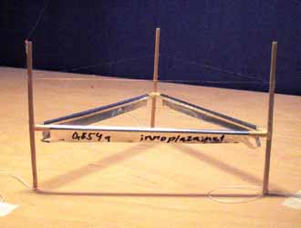
Figure 1. Downward looking view of a Biefield-Brown Effect “lifter” or model antigravity device [1].

References
[1] Hartikka, J. (2015) “Straw Lifter Experiment”, Web image. http://www.guns.connect.fi/ innoplaza/energy/plasma/lifter/index.html (accessed 27 Oct 2015).

