CGS 2531 MyITLab Tips
How to access the assignments
- Click Course Materials. In the right panel, click Assignments. (Don’t worry about the Assignment Calendar tab and the To Do/Completed list)
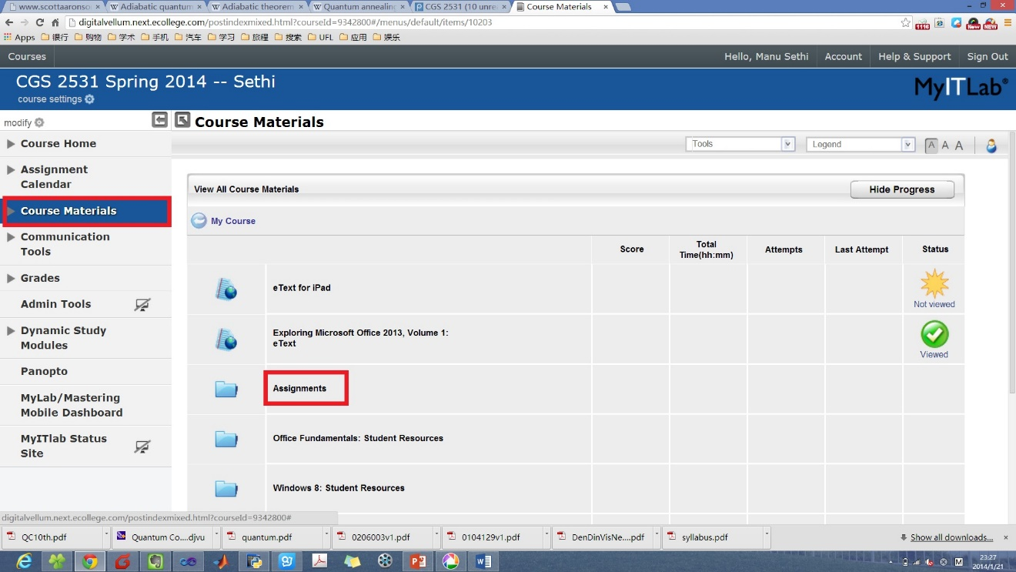
- In the list of assignments, click the triangle button next to the assignment you want to access. In the context menu, click Open.
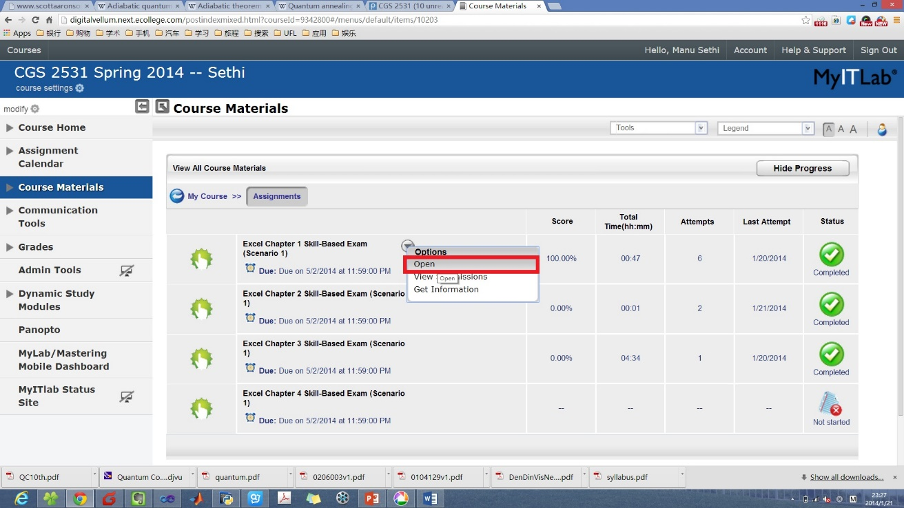
- The simulation environment of the assignment will pop up. Then you can do the assignment.
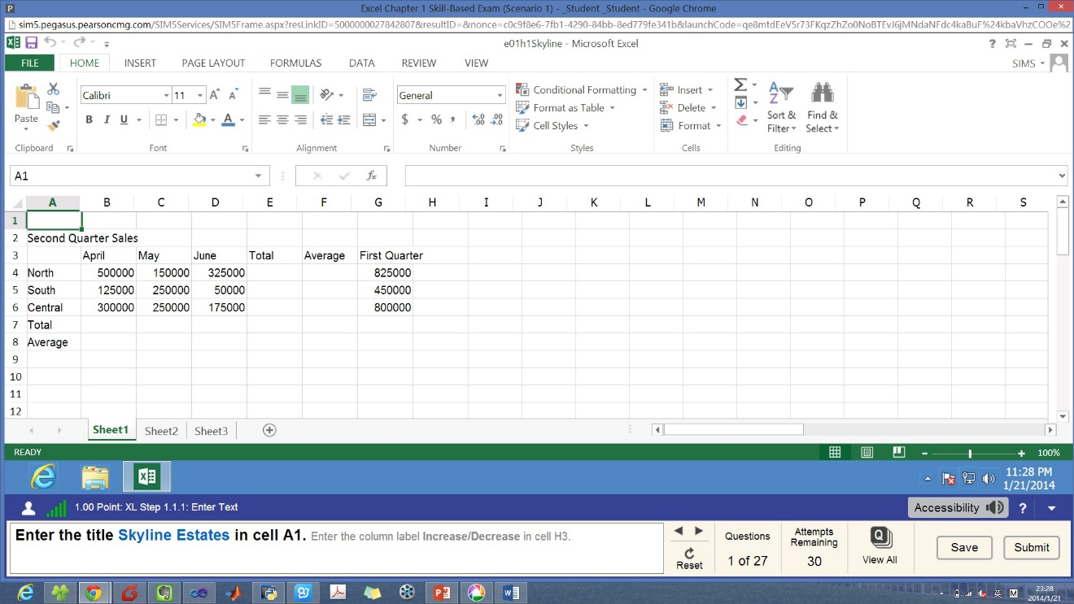

How to see answers after submitting the homework
- Click the Grades button. In the right panel, click Assignments.
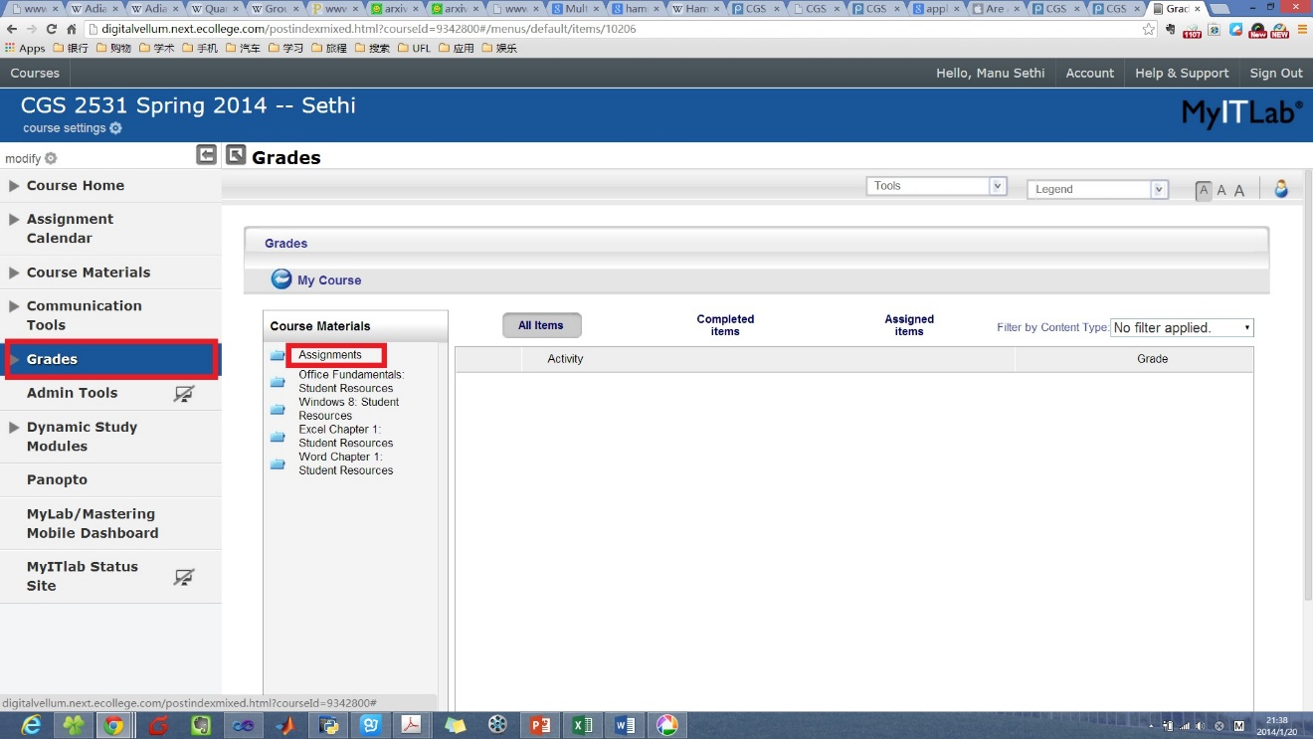
- Click the assignment that you have submitted.
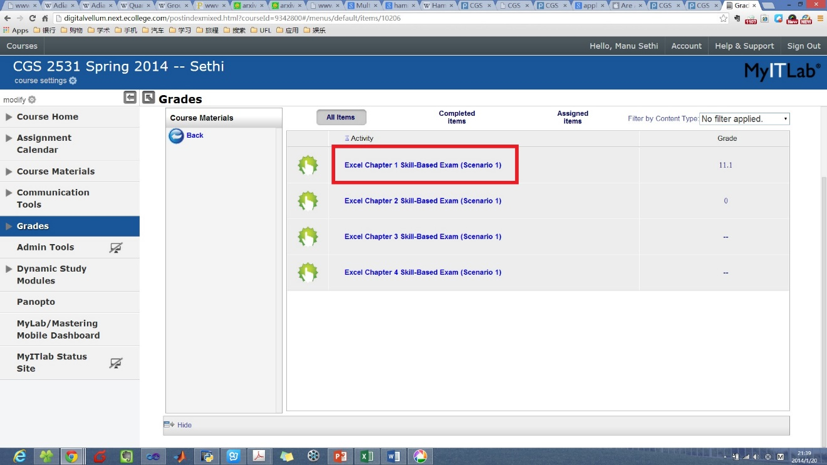
- Click the triangle button next to the assignment to pop up the context menu. Click View Submissions.
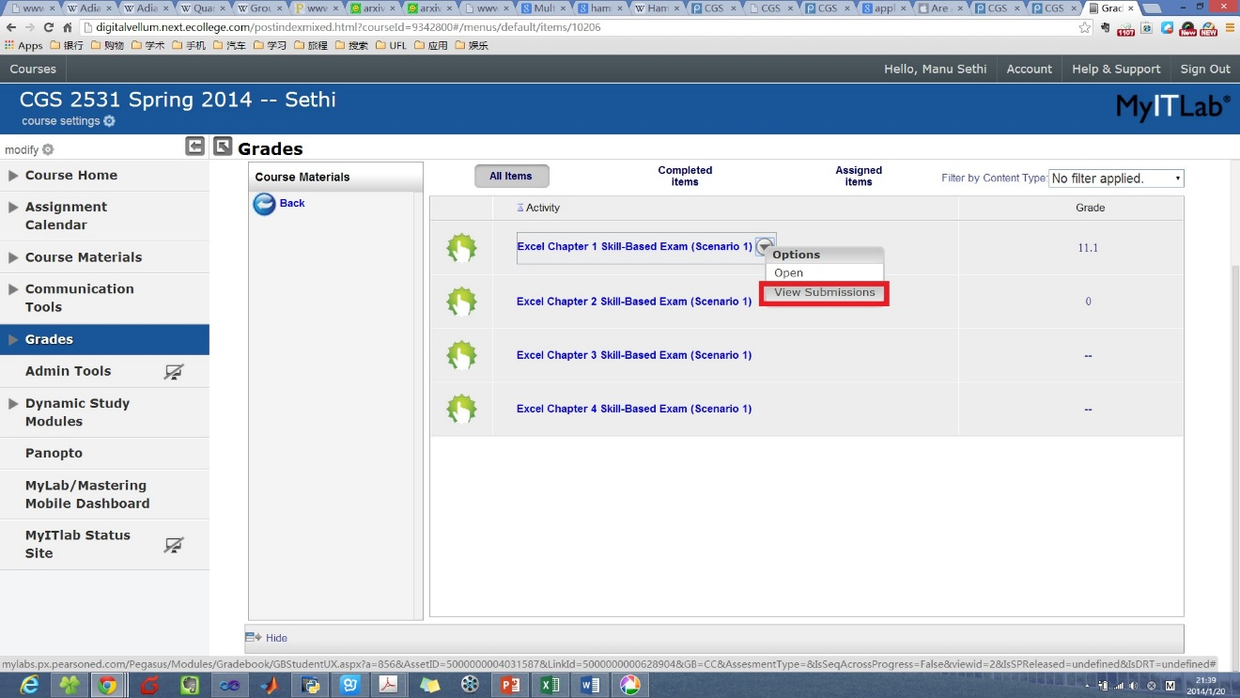
- Click the submission you want to check.
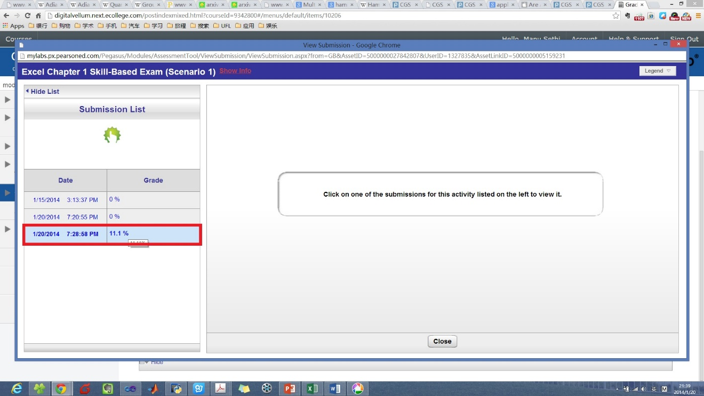
- In the right panel, you can check the incorrectly answered questions and see the answers to each question.
